UNITED STATES
SECURITIES AND EXCHANGE COMMISSION
WASHINGTON, D.C. 20549
_____________________________________________
FORM 8-K
_____________________________________________
CURRENT REPORT
Pursuant to Section 13 or 15(d) of the Securities Exchange Act of 1934
Date of Report (Date of earliest event reported): August 31, 2026
_____________________________________________
Vaxcyte, Inc.
(Exact name of Registrant as Specified in Its Charter)
_____________________________________________
Delaware |  |  | 01-39323 |  |  | 46-4233385
(State or Other Jurisdiction  of Incorporation) |  |  | (Commission File Number) |  |  | (IRS Employer  Identification No.)
825 Industrial Road  Suite 300  San Carlos , California |  |  |  |  |  | 94070
(Address of Principal Executive Offices) |  |  |  |  |  | (Zip Code)
Registrant’s Telephone Number, Including Area Code: (650) 837-0111
Not Applicable
(Former Name or Former Address, if Changed Since Last Report)
_____________________________________________
Check the appropriate box below if the Form 8-K filing is intended to simultaneously satisfy the filing obligation of the registrant under any of the following provisions:
o |  |  | Written communications pursuant to Rule 425 under the Securities Act (17 CFR 230.425)
o |  |  | Soliciting material pursuant to Rule 14a-12 under the Exchange Act (17 CFR 240.14a-12)
o |  |  | Pre-commencement communications pursuant to Rule 14d-2(b) under the Exchange Act (17 CFR 240.14d-2(b))
o |  |  | Pre-commencement communications pursuant to Rule 13e-4(c) under the Exchange Act (17 CFR 240.13e-4(c))
Securities registered pursuant to Section 12(b) of the Act:
Title of each class |  |  |  |  |  | Trading  Symbol(s) |  |  |  |  |  | Name of each exchange on which registered
Common Stock, $0.001 par value per share |  |  |  |  |  | PCVX |  |  |  |  |  | The Nasdaq Stock Market LLC
Indicate by check mark whether the registrant is an emerging growth company as defined in Rule 405 of the Securities Act of 1933 (§ 230.405 of this chapter) or Rule 12b-2 of the Securities Exchange Act of 1934 (§ 240.12b-2 of this chapter).
Emerging growth company o
If an emerging growth company, indicate by check mark if the registrant has elected not to use the extended transition period for complying with any new or revised financial accounting standards provided pursuant to Section 13(a) of the Exchange Act. o

Item 5.02. Departure of Directors or Certain Officers; Election of Directors; Appointment of Certain
Officers; Compensatory Arrangements of Certain Officers.
On August 31, 2026, Vaxcyte, Inc. (the “Company”) appointed David McAvoy as the Company's Chief Legal Officer, Chief Compliance Officer, and Corporate Secretary. Mikhail Eydelman continues to serve as Senior Vice President, General Counsel.
Item 7.01. Regulation FD Disclosure.
On September 3, 2026, the Company issued a press release titled "Vaxcyte Appoints Chief Medical Officer and Chief Legal Officer; Narrows Guidance for Expected VAX-31 OPUS-1 Topline Data." A copy of the press release is furnished as Exhibit 99.1 to this Current Report on Form 8-K and is incorporated herein by reference.
The information in this Item 7.01 and Exhibit 99.1 attached hereto is intended to be furnished and shall not be deemed to be "filed" for purposes of Section 18 of the Securities Exchange Act of 1934, as amended (the "Exchange Act"), or otherwise subject to the liabilities of that section, nor shall it be deemed incorporated by reference into any registration statement or other document filed under the Securities Act of 1933, as amended, or the Exchange Act, except as shall be expressly set forth by specific reference in such filing.

Item 9.01. Financial Statements and Exhibits.

(d) Exhibits
Exhibit  Number |  |  |  |  |  | Description
99.1 |  |  |  |  |  | Press Release of Vaxcyte, Inc., dated September 3, 2026
104 |  |  |  |  |  | Cover Page Interactive Data File (embedded within the Inline XBRL document).

SIGNATURES
Pursuant to the requirements of the Securities Exchange Act of 1934, the registrant has duly caused this report to be signed on its behalf by the undersigned thereunto duly authorized.

 |  |  |  |  |  |  |  |  |  |  |  |  |  |  |  |  |  | VAXCYTE, INC.
Date: September 3, 2026 |  |  |  |  |  |  |  |  |  |  |  | By: |  |  |  |  |  | /s/ Andrew Guggenhime
Andrew Guggenhime
President and Chief Financial Officer

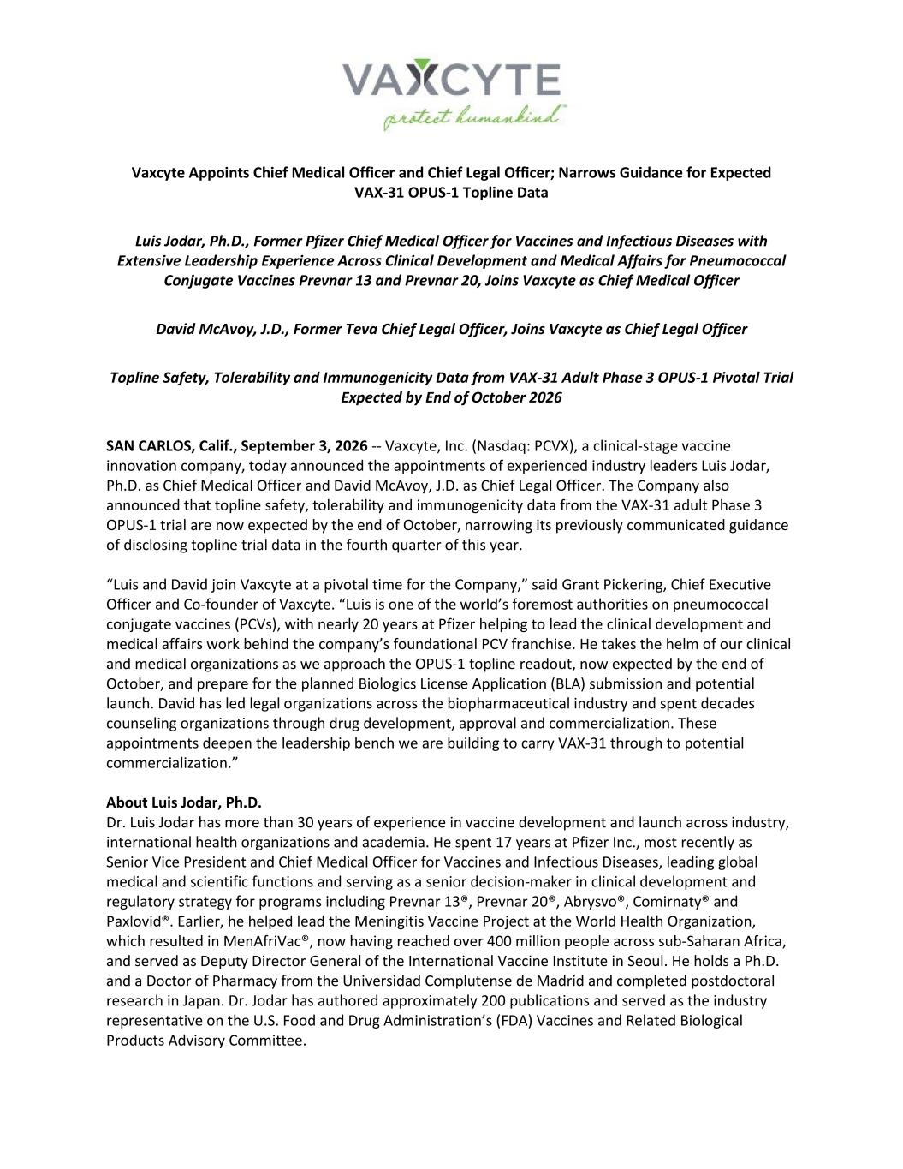

Vaxcyte Appoints Chief Medical Officer and Chief Legal Officer; Narrows Guidance for Expected VAX-31 OPUS-1 Topline Data Luis Jodar, Ph.D., Former Pfizer Chief Medical Officer for Vaccines and Infectious Diseases with Extensive Leadership Experience Across Clinical Development and Medical Affairs for Pneumococcal Conjugate Vaccines Prevnar 13 and Prevnar 20, Joins Vaxcyte as Chief Medical Officer David McAvoy, J.D., Former Teva Chief Legal Officer, Joins Vaxcyte as Chief Legal Officer Topline Safety, Tolerability and Immunogenicity Data from VAX-31 Adult Phase 3 OPUS-1 Pivotal Trial Expected by End of October 2026 SAN CARLOS, Calif., September 3, 2026 -- Vaxcyte, Inc. (Nasdaq: PCVX), a clinical-stage vaccine innovation company, today announced the appointments of experienced industry leaders Luis Jodar, Ph.D. as Chief Medical Officer and David McAvoy, J.D. as Chief Legal Officer. The Company also announced that topline safety, tolerability and immunogenicity data from the VAX-31 adult Phase 3 OPUS-1 trial are now expected by the end of October, narrowing its previously communicated guidance of disclosing topline trial data in the fourth quarter of this year. “Luis and David join Vaxcyte at a pivotal time for the Company,” said Grant Pickering, Chief Executive Officer and Co-founder of Vaxcyte. “Luis is one of the world’s foremost authorities on pneumococcal conjugate vaccines (PCVs), with nearly 20 years at Pfizer helping to lead the clinical development and medical affairs work behind the company’s foundational PCV franchise. He takes the helm of our clinical and medical organizations as we approach the OPUS-1 topline readout, now expected by the end of October, and prepare for the planned Biologics License Application (BLA) submission and potential launch. David has led legal organizations across the biopharmaceutical industry and spent decades counseling organizations through drug development, approval and commercialization. These appointments deepen the leadership bench we are building to carry VAX-31 through to potential commercialization.” About Luis Jodar, Ph.D. Dr. Luis Jodar has more than 30 years of experience in vaccine development and launch across industry, international health organizations and academia. He spent 17 years at Pfizer Inc., most recently as Senior Vice President and Chief Medical Officer for Vaccines and Infectious Diseases, leading global medical and scientific functions and serving as a senior decision-maker in clinical development and regulatory strategy for programs including Prevnar 13®, Prevnar 20®, Abrysvo®, Comirnaty® and Paxlovid®. Earlier, he helped lead the Meningitis Vaccine Project at the World Health Organization, which resulted in MenAfriVac®, now having reached over 400 million people across sub-Saharan Africa, and served as Deputy Director General of the International Vaccine Institute in Seoul. He holds a Ph.D. and a Doctor of Pharmacy from the Universidad Complutense de Madrid and completed postdoctoral research in Japan. Dr. Jodar has authored approximately 200 publications and served as the industry representative on the U.S. Food and Drug Administration’s (FDA) Vaccines and Related Biological Products Advisory Committee.

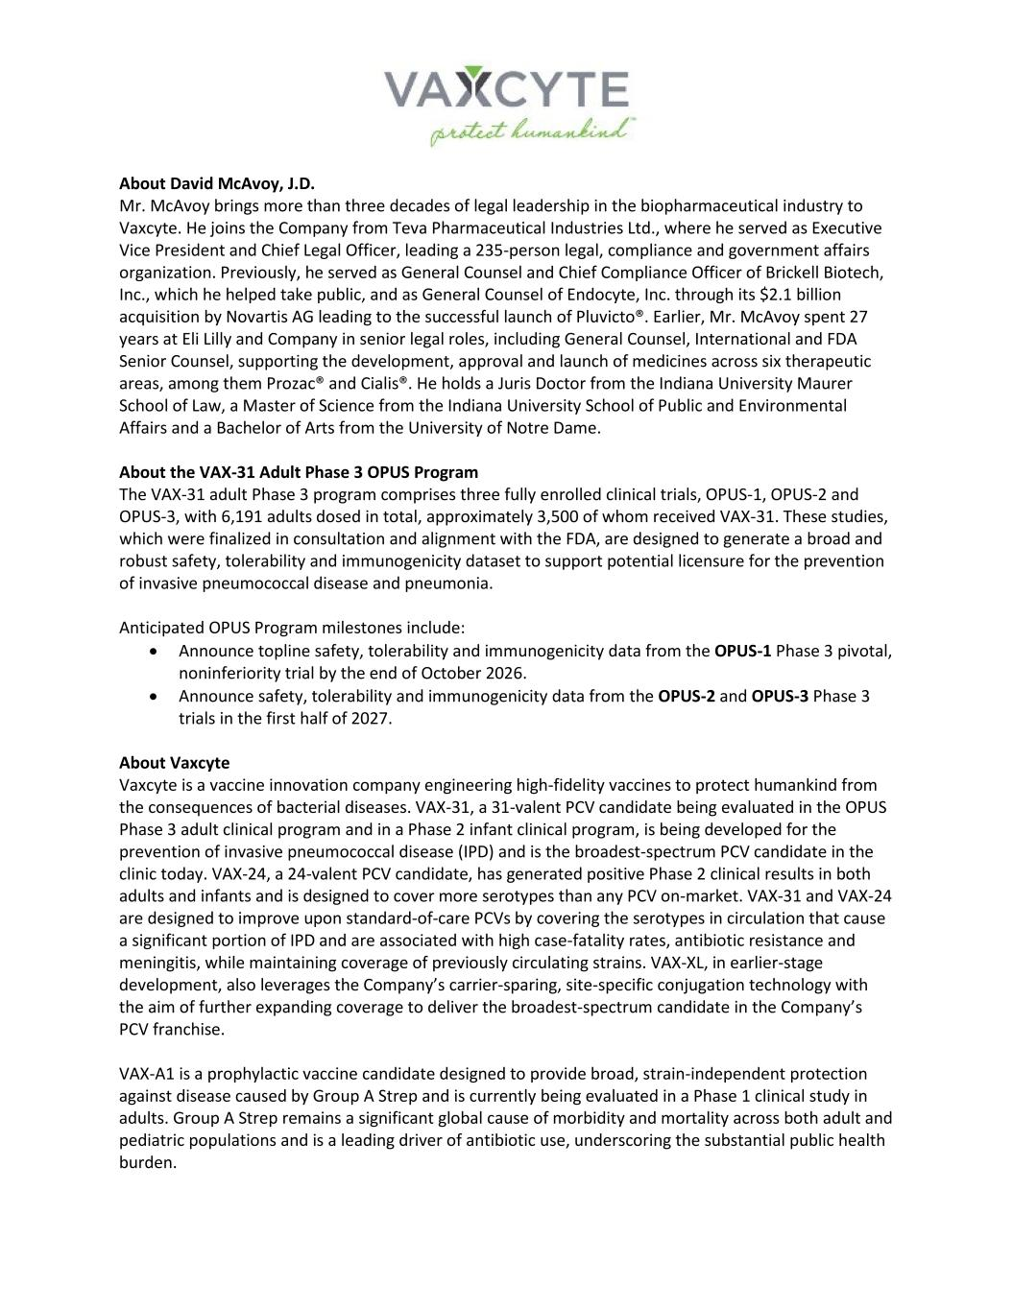
About David McAvoy, J.D. Mr. McAvoy brings more than three decades of legal leadership in the biopharmaceutical industry to Vaxcyte. He joins the Company from Teva Pharmaceutical Industries Ltd., where he served as Executive Vice President and Chief Legal Officer, leading a 235-person legal, compliance and government affairs organization. Previously, he served as General Counsel and Chief Compliance Officer of Brickell Biotech, Inc., which he helped take public, and as General Counsel of Endocyte, Inc. through its $2.1 billion acquisition by Novartis AG leading to the successful launch of Pluvicto®. Earlier, Mr. McAvoy spent 27 years at Eli Lilly and Company in senior legal roles, including General Counsel, International and FDA Senior Counsel, supporting the development, approval and launch of medicines across six therapeutic areas, among them Prozac® and Cialis®. He holds a Juris Doctor from the Indiana University Maurer School of Law, a Master of Science from the Indiana University School of Public and Environmental Affairs and a Bachelor of Arts from the University of Notre Dame. About the VAX-31 Adult Phase 3 OPUS Program The VAX-31 adult Phase 3 program comprises three fully enrolled clinical trials, OPUS-1, OPUS-2 and OPUS-3, with 6,191 adults dosed in total, approximately 3,500 of whom received VAX-31. These studies, which were finalized in consultation and alignment with the FDA, are designed to generate a broad and robust safety, tolerability and immunogenicity dataset to support potential licensure for the prevention of invasive pneumococcal disease and pneumonia. Anticipated OPUS Program milestones include: • Announce topline safety, tolerability and immunogenicity data from the OPUS-1 Phase 3 pivotal, noninferiority trial by the end of October 2026. • Announce safety, tolerability and immunogenicity data from the OPUS-2 and OPUS-3 Phase 3 trials in the first half of 2027. About Vaxcyte Vaxcyte is a vaccine innovation company engineering high-fidelity vaccines to protect humankind from the consequences of bacterial diseases. VAX-31, a 31-valent PCV candidate being evaluated in the OPUS Phase 3 adult clinical program and in a Phase 2 infant clinical program, is being developed for the prevention of invasive pneumococcal disease (IPD) and is the broadest-spectrum PCV candidate in the clinic today. VAX-24, a 24-valent PCV candidate, has generated positive Phase 2 clinical results in both adults and infants and is designed to cover more serotypes than any PCV on-market. VAX-31 and VAX-24 are designed to improve upon standard-of-care PCVs by covering the serotypes in circulation that cause a significant portion of IPD and are associated with high case-fatality rates, antibiotic resistance and meningitis, while maintaining coverage of previously circulating strains. VAX-XL, in earlier-stage development, also leverages the Company’s carrier-sparing, site-specific conjugation technology with the aim of further expanding coverage to deliver the broadest-spectrum candidate in the Company’s PCV franchise. VAX-A1 is a prophylactic vaccine candidate designed to provide broad, strain-independent protection against disease caused by Group A Strep and is currently being evaluated in a Phase 1 clinical study in adults. Group A Strep remains a significant global cause of morbidity and mortality across both adult and pediatric populations and is a leading driver of antibiotic use, underscoring the substantial public health burden.

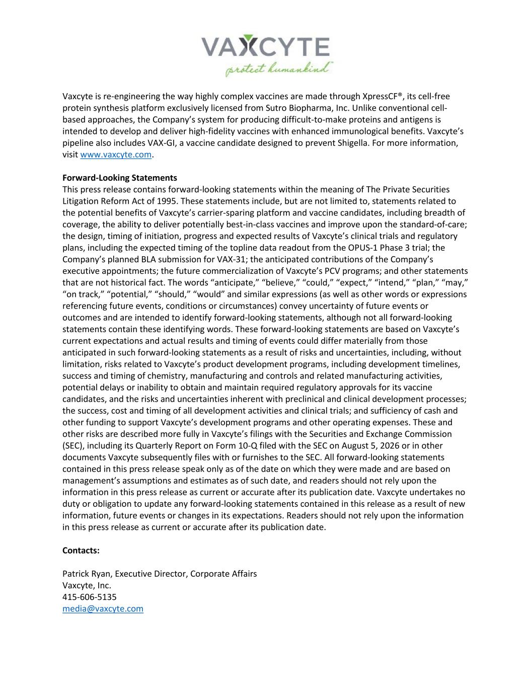
Vaxcyte is re-engineering the way highly complex vaccines are made through XpressCF®, its cell-free protein synthesis platform exclusively licensed from Sutro Biopharma, Inc. Unlike conventional cell- based approaches, the Company’s system for producing difficult-to-make proteins and antigens is intended to develop and deliver high-fidelity vaccines with enhanced immunological benefits. Vaxcyte’s pipeline also includes VAX-GI, a vaccine candidate designed to prevent Shigella. For more information, visit www.vaxcyte.com. Forward-Looking Statements This press release contains forward-looking statements within the meaning of The Private Securities Litigation Reform Act of 1995. These statements include, but are not limited to, statements related to the potential benefits of Vaxcyte’s carrier-sparing platform and vaccine candidates, including breadth of coverage, the ability to deliver potentially best-in-class vaccines and improve upon the standard-of-care; the design, timing of initiation, progress and expected results of Vaxcyte’s clinical trials and regulatory plans, including the expected timing of the topline data readout from the OPUS-1 Phase 3 trial; the Company’s planned BLA submission for VAX-31; the anticipated contributions of the Company’s executive appointments; the future commercialization of Vaxcyte’s PCV programs; and other statements that are not historical fact. The words “anticipate,” “believe,” “could,” “expect,” “intend,” “plan,” “may,” “on track,” “potential,” “should,” “would” and similar expressions (as well as other words or expressions referencing future events, conditions or circumstances) convey uncertainty of future events or outcomes and are intended to identify forward-looking statements, although not all forward-looking statements contain these identifying words. These forward-looking statements are based on Vaxcyte’s current expectations and actual results and timing of events could differ materially from those anticipated in such forward-looking statements as a result of risks and uncertainties, including, without limitation, risks related to Vaxcyte’s product development programs, including development timelines, success and timing of chemistry, manufacturing and controls and related manufacturing activities, potential delays or inability to obtain and maintain required regulatory approvals for its vaccine candidates, and the risks and uncertainties inherent with preclinical and clinical development processes; the success, cost and timing of all development activities and clinical trials; and sufficiency of cash and other funding to support Vaxcyte’s development programs and other operating expenses. These and other risks are described more fully in Vaxcyte’s filings with the Securities and Exchange Commission (SEC), including its Quarterly Report on Form 10-Q filed with the SEC on August 5, 2026 or in other documents Vaxcyte subsequently files with or furnishes to the SEC. All forward-looking statements contained in this press release speak only as of the date on which they were made and are based on management’s assumptions and estimates as of such date, and readers should not rely upon the information in this press release as current or accurate after its publication date. Vaxcyte undertakes no duty or obligation to update any forward-looking statements contained in this release as a result of new information, future events or changes in its expectations. Readers should not rely upon the information in this press release as current or accurate after its publication date. Contacts: Patrick Ryan, Executive Director, Corporate Affairs Vaxcyte, Inc. 415-606-5135 media@vaxcyte.com


Jeff Macdonald, Executive Director, Investor Relations Vaxcyte, Inc. 917-371-0940 investors@vaxcyte.com

