SEC Form 4

FORM 4

Check this box if no longer subject to Section 16. Form 4 or Form 5 obligations may continue. See Instruction 1(b).

UNITED STATES SECURITIES AND EXCHANGE COMMISSION
Washington, D.C. 20549
 |  | OMB APPROVAL
STATEMENT OF CHANGES IN BENEFICIAL OWNERSHIP
 |  | OMB Number: | 3235-0287
 |  | Estimated average burden
Filed pursuant to Section 16(a) of the Securities Exchange Act of 1934 |  | hours per response: | 0.5
or Section 30(h) of the Investment Company Act of 1940
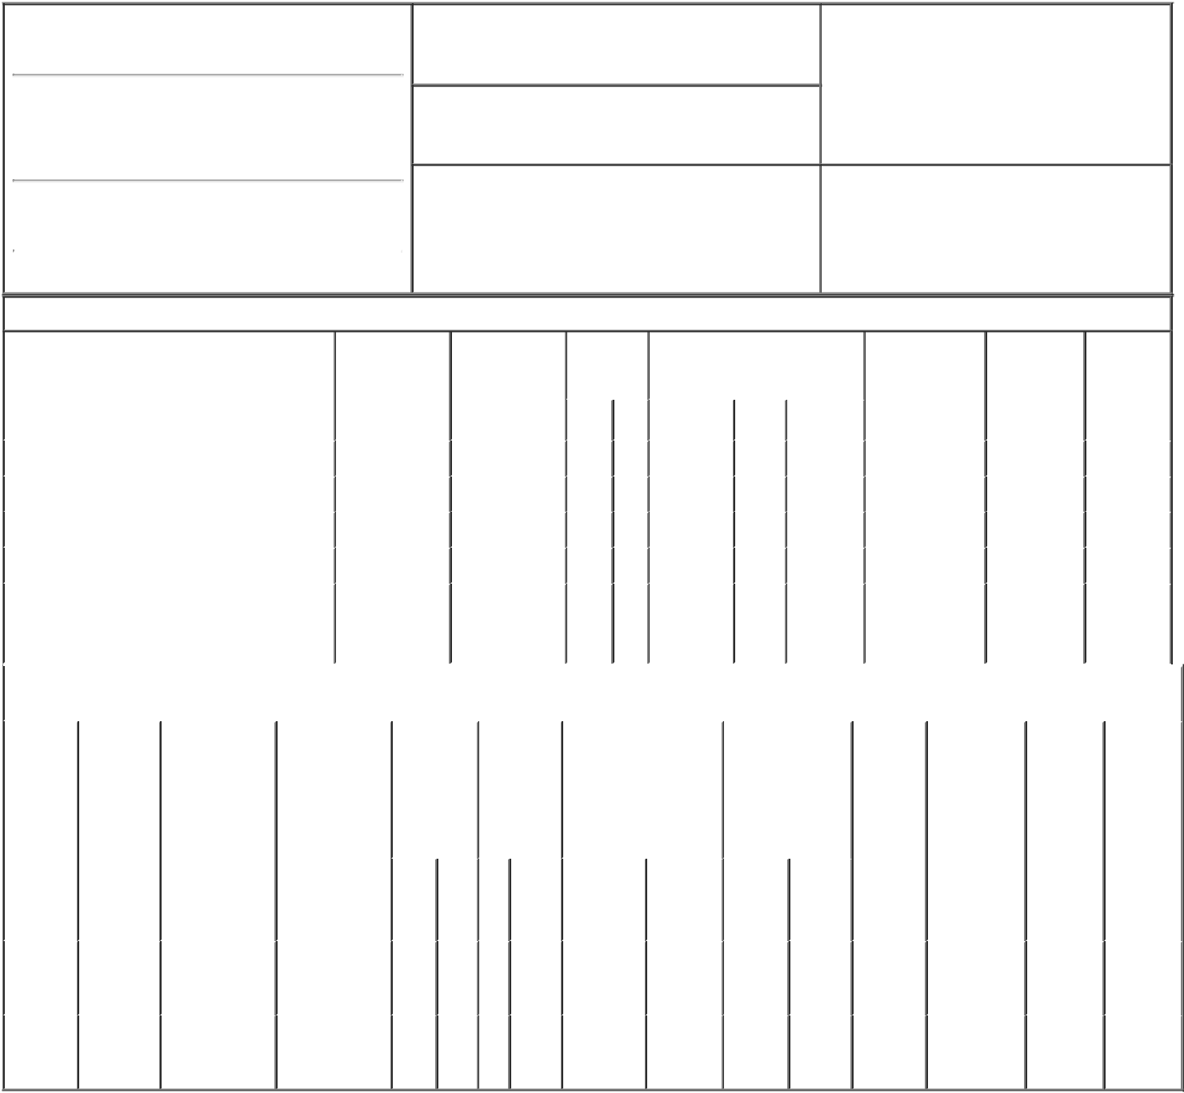

1. Name and Address of Reporting Person*
PICKERING GRANT

(Last) (First) (Middle)

C/O VAXCYTE, INC.

353 HATCH DRIVE

2. Issuer Name and Ticker or Trading Symbol

Vaxcyte, Inc. [ PCVX ]

3. Date of Earliest Transaction (Month/Day/Year)

05/27/2021

- Relationship of Reporting Person(s) to Issuer (Check all applicable)

X | Director | 10% Owner
X | Officer (give title | Other (specify
 | below) | below)

Chief Executive Officer

(Street)
 | FOSTER CITY | CA | 94404
 | (City) | (State) | (Zip)

4. If Amendment, Date of Original Filed (Month/Day/Year) 6. Individual or Joint/Group Filing (Check Applicable
Line)
X Form filed by One Reporting Person

Form filed by More than One Reporting
Person

Table I - Non-Derivative Securities Acquired, Disposed of, or Beneficially Owned

 | 1. Title of Security (Instr. 3) |  |  | 2. Transaction |  | 2A. Deemed |  | 3. | 4. Securities Acquired (A) or |  |  |  |  | 5. Amount of |  | 6. Ownership |  | 7. Nature of
 |  |  |  | Date |  | Execution Date, |  | Transaction | Disposed Of (D) (Instr. 3, 4 and 5) |  |  |  |  | Securities |  | Form: Direct |  | Indirect
 |  |  |  | (Month/Day/Year) |  | if any |  | Code (Instr. |  |  |  |  |  | Beneficially |  | (D) or Indirect |  | Beneficial
 |  |  |  |  |  | (Month/Day/Year) |  | 8) |  |  |  |  |  | Owned Following |  | (I) (Instr. 4) |  | Ownership
 |  |  |  |  |  |  |  |  |  |  |  |  |  | Reported |  |  |  | (Instr. 4)
 |  |  |  |  |  |  |  | Code V | Amount | (A) or | Price |  |  | Transaction(s)
 |  |  |  |  |  |  |  |  |  | (D) |  |  |  | (Instr. 3 and 4)
 | Common Stock |  |  | 05/27/2021 |  |  |  | M | 12,246 | A | $1.79 |  | 592,500⁽¹⁾ |  |  |  | D
 | Common Stock |  |  | 05/27/2021 |  |  |  | _{S}(2) | 12,246 | D | $22.1⁽³⁾ |  | 580,254 |  |  |  | D
 | Common Stock |  |  | 05/28/2021 |  |  |  | M | 2,656 | A | $1.79 |  | 582,910 |  |  |  | D
 | Common Stock |  |  | 05/28/2021 |  |  |  | _{S}(2) | 2,656 | D | $22.16⁽⁴⁾ |  | 580,254 |  |  |  | D
 |  |  |  |  |  |  |  |  |  |  |  |  |  |  |  |  |  | By
 | Common Stock |  |  |  |  |  |  |  |  |  |  |  | 355,660 |  |  |  | I | Children's
 |  |  |  |  |  |  |  |  |  |  |  |  |  |  |  |  |  | Trusts
 |  |  |  | Table II - Derivative Securities Acquired, Disposed of, or Beneficially Owned
 |  |  |  | (e.g., puts, calls, warrants, options, convertible securities)
 | 1. Title of | 2. | 3. Transaction | 3A. Deemed | 4. |  | 5. Number | 6. Date Exercisable and |  | 7. Title and Amount |  |  | 8. Price of |  | 9. Number of |  | 10. |  | 11. Nature
 | Derivative | Conversion | Date | Execution Date, | Transaction |  | of | Expiration Date |  | of Securities |  |  | Derivative |  | derivative |  | Ownership |  | of Indirect
 | Security | or Exercise | (Month/Day/Year) | if any | Code (Instr. |  | Derivative | (Month/Day/Year) |  | Underlying |  |  | Security |  | Securities |  | Form: |  | Beneficial
 | (Instr. 3) | Price of |  | (Month/Day/Year) | 8) |  | Securities |  |  | Derivative Security |  |  | (Instr. 5) |  | Beneficially |  | Direct (D) |  | Ownership
 |  | Derivative |  |  |  |  | Acquired |  |  | (Instr. 3 and 4) |  |  |  |  | Owned |  | or Indirect |  | (Instr. 4)
 |  | Security |  |  |  |  | (A) or |  |  |  |  |  |  |  | Following |  | (I) (Instr. 4)
 |  |  |  |  |  |  | Disposed |  |  |  |  |  |  |  | Reported
 |  |  |  |  |  |  | of (D) (Instr. |  |  |  |  |  |  |  | Transaction(s)
 |  |  |  |  |  |  | 3, 4 and 5) |  |  |  |  |  |  |  | (Instr. 4)
 |  |  |  |  |  |  |  |  |  |  | Amount
 |  |  |  |  |  |  |  |  |  |  | or
 |  |  |  |  |  |  |  |  |  |  | Number
 |  |  |  |  |  |  |  | Date | Expiration |  | of
 |  |  |  |  | Code V |  | (A) (D) | Exercisable | Date | Title | Shares
 | Stock
 | Option | $1.79 | 05/27/2021 |  | M |  | 12,246 | (5) | 05/17/2027 | Common | 12,246 |  | $0.00 |  | 436,569 |  | D
 | (right to |  |  |  |  |  |  |  |  | Stock
 | buy)
 | Stock
 | Option | $1.79 | 05/28/2021 |  | M |  | 2,656 | (5) | 05/17/2027 | Common | 2,656 |  | $0.00 |  | 433,913 |  | D
 | (right to |  |  |  |  |  |  |  |  | Stock
buy)

Explanation of Responses:

- Includes 1,563 shares acquired under the Employee Stock Purchase Plan on May 17, 2021.

- The sales reported on this Form 4 were effected pursuant to a Rule 10b5-1 trading plan.

- The price reported is a weighted-average price. The shares were sold at prices ranging from $22.00 to $22.29. The reporting person will provide upon request to the SEC, the issuer or security holder of the issuer, full information regarding the number of shares sold at each separate price.

- The price reported is a weighted-average price. The shares were sold at prices ranging from $22.00 to $22.405. The reporting person will provide upon request to the SEC, the issuer or security holder of the issuer, full information regarding the number of shares sold at each separate price.

- The shares subject to the option are fully vested and exercisable.

Remarks:

/s/ Winston Macaraeg, |  |  | 05/28/2021
Attorney-in-Fact
** Signature of Reporting Person |  |  | Date

Reminder: Report on a separate line for each class of securities beneficially owned directly or indirectly.

* If the form is filed by more than one reporting person, see Instruction 4 (b)(v).

- Intentional misstatements or omissions of facts constitute Federal Criminal Violations See 18 U.S.C. 1001 and 15 U.S.C. 78ff(a). Note: File three copies of this Form, one of which must be manually signed. If space is insufficient, see Instruction 6 for procedure.
Persons who respond to the collection of information contained in this form are not required to respond unless the form displays a currently valid OMB Number.

