SEC Form 4

FORM 4

Check this box if no longer subject to Section 16. Form 4 or Form 5 obligations may continue. See Instruction 1(b).

UNITED STATES SECURITIES AND EXCHANGE COMMISSION
Washington, D.C. 20549
 |  | OMB APPROVAL
STATEMENT OF CHANGES IN BENEFICIAL OWNERSHIP
 |  | OMB Number: | 3235-0287
 |  | Estimated average burden
Filed pursuant to Section 16(a) of the Securities Exchange Act of 1934 |  | hours per response: | 0.5
or Section 30(h) of the Investment Company Act of 1940
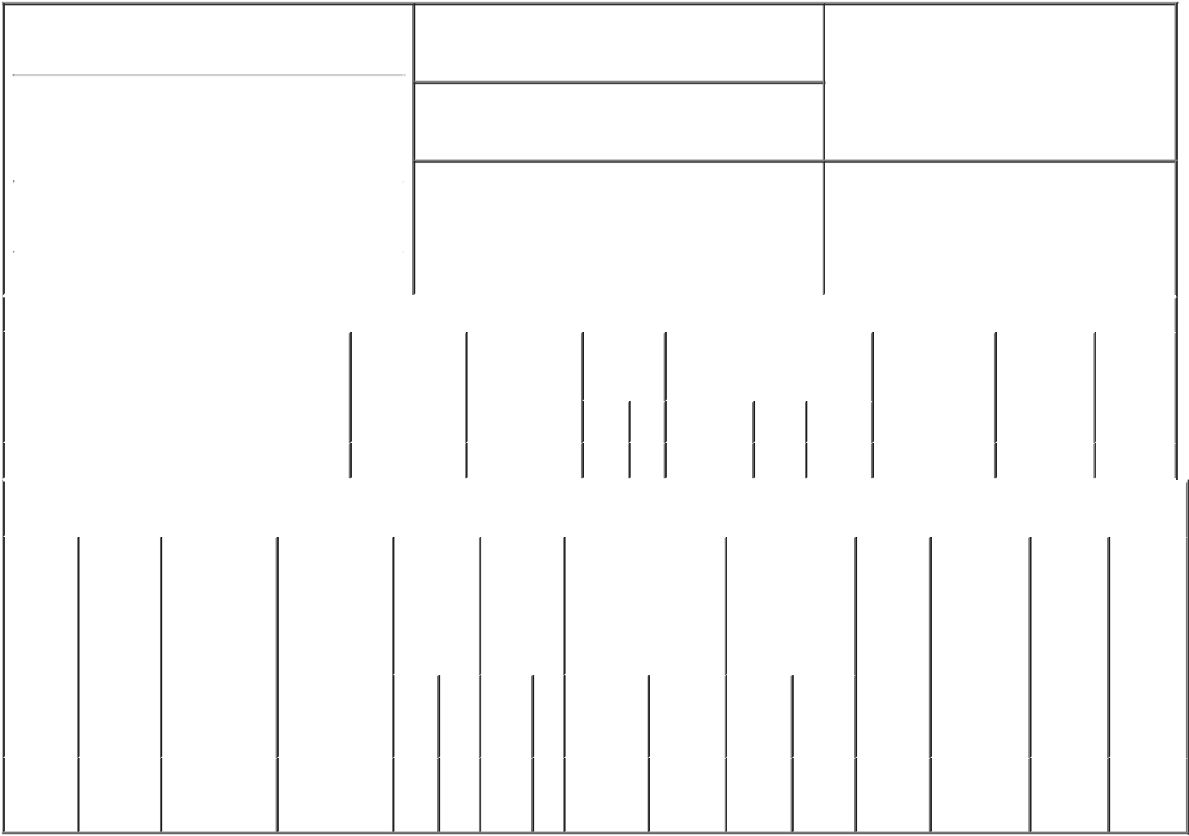

1. Name and Address of Reporting Person*
Cowan Elvia

(Last) (First) (Middle)

C/O VAXCYTE, INC.

825 INDUSTRIAL ROAD, SUITE 300

2. Issuer Name and Ticker or Trading Symbol

Vaxcyte, Inc. [ PCVX ]

3. Date of Earliest Transaction (Month/Day/Year)

03/01/2023

- Relationship of Reporting Person(s) to Issuer (Check all applicable)

 | Director | 10% Owner
X | Officer (give title | Other (specify
 | below) | below)

SVP, Finance

 |  |  |  |  |  |  | 4. If Amendment, Date of Original Filed (Month/Day/Year) |  |  |  |  |  |  |  |  | 6. Individual or Joint/Group Filing (Check Applicable
 | (Street) |  |  |  |  |  |  |  |  |  |  |  |  |  |  | Line)
 |  |  |  |  |  |  |  |  |  |  |  |  |  |  |  | X Form filed by One Reporting Person
 |  | SAN CARLOS CA |  |  | 94070
 |  |  |  |  |  |  |  |  |  |  |  |  |  |  |  |  |  |  | Form filed by More than One Reporting
 |  |  |  |  |  |  |  |  |  |  |  |  |  |  |  |  |  |  | Person
 |  | (City) | (State) |  | (Zip)
 |  |  |  | Table I - Non-Derivative Securities Acquired, Disposed of, or Beneficially Owned
 | 1. Title of Security (Instr. 3) |  |  |  | 2. Transaction |  |  | 2A. Deemed |  | 3. |  |  | 4. Securities Acquired (A) or |  |  |  |  |  | 5. Amount of |  | 6. Ownership |  | 7. Nature
 |  |  |  |  | Date |  |  | Execution Date, |  |  | Transaction |  | Disposed Of (D) (Instr. 3, 4 and |  |  |  |  |  | Securities |  | Form: Direct |  | of Indirect
 |  |  |  |  | (Month/Day/Year) |  |  | if any |  |  | Code (Instr. |  | 5) |  |  |  |  |  | Beneficially |  | (D) or Indirect |  | Beneficial
 |  |  |  |  |  |  |  | (Month/Day/Year) 8) |  |  |  |  |  |  |  |  |  |  | Owned Following |  | (I) (Instr. 4) |  | Ownership
 |  |  |  |  |  |  |  |  |  |  |  |  |  |  |  |  |  |  | Reported |  |  |  | (Instr. 4)
 |  |  |  |  |  |  |  |  |  |  | Code V |  | Amount |  | (A) or | Price |  |  | Transaction(s)
 |  |  |  |  |  |  |  |  |  |  |  |  |  |  | (D) |  |  |  | (Instr. 3 and 4)
 | Common Stock |  |  |  | 03/01/2023 |  |  |  |  |  | A |  | 7,250⁽¹⁾ |  | A | $0.00 |  | 7,250 |  |  |  | D
 |  |  |  |  | Table II - Derivative Securities Acquired, Disposed of, or Beneficially Owned
 |  |  |  |  | (e.g., puts, calls, warrants, options, convertible securities)
 | 1. Title of |  | 2. | 3. Transaction | 3A. Deemed | 4. |  | 5. Number |  | 6. Date Exercisable and |  |  |  | 7. Title and Amount |  |  |  | 8. Price of |  | 9. Number of |  | 10. | 11. Nature
 | Derivative |  | Conversion | Date | Execution Date, | Transaction |  | of |  | Expiration Date |  |  |  | of Securities |  |  |  | Derivative |  | derivative |  | Ownership | of Indirect
 | Security |  | or Exercise | (Month/Day/Year) | if any | Code (Instr. |  | Derivative |  | (Month/Day/Year) |  |  |  | Underlying |  |  |  | Security |  | Securities |  | Form: | Beneficial
 | (Instr. 3) |  | Price of |  | (Month/Day/Year) | 8) |  | Securities |  |  |  |  |  | Derivative Security |  |  |  | (Instr. 5) |  | Beneficially |  | Direct (D) | Ownership
 |  |  | Derivative |  |  |  |  | Acquired |  |  |  |  |  | (Instr. 3 and 4) |  |  |  |  |  | Owned |  | or Indirect | (Instr. 4)
 |  |  | Security |  |  |  |  | (A) or |  |  |  |  |  |  |  |  |  |  |  | Following |  | (I) (Instr. 4)
 |  |  |  |  |  |  |  | Disposed |  |  |  |  |  |  |  |  |  |  |  | Reported
 |  |  |  |  |  |  |  | of (D) (Instr. |  |  |  |  |  |  |  |  |  |  |  | Transaction(s)
 |  |  |  |  |  |  |  | 3, 4 and 5) |  |  |  |  |  |  |  |  |  |  |  | (Instr. 4)
 |  |  |  |  |  |  |  |  |  |  |  |  |  |  |  | Amount
 |  |  |  |  |  |  |  |  |  |  |  |  |  |  |  | or
 |  |  |  |  |  |  |  |  |  |  |  |  |  |  |  | Number
 |  |  |  |  |  |  |  |  |  | Date |  | Expiration |  |  |  | of
 |  |  |  |  |  | Code V |  | (A) | (D) | Exercisable |  | Date |  | Title |  | Shares
 | Stock
 | Option |  | $41.67 | 03/01/2023 |  |  | A | 43,500 |  | (2) |  | 03/01/2033 |  | Common |  | 43,500 |  | $0.00 |  | 43,500 |  | D
 | (right to |  |  |  |  |  |  |  |  |  |  |  |  |  | Stock
buy)

Explanation of Responses:

- Represents the number of shares of Common Stock underlying restricted stock units ("RSUs"). Each RSU represents the contingent right to receive one share of the Issuer's Common Stock. The RSUs vest as to 25% of the shares subject to the award on September 2, 2023 and 12.5% of the shares every six months thereafter, subject to Reporting Person's continuous service with the Issuer through each such date.
- 1/48 of shares subject to the option vest on April 1, 2023, and 1/48 of the shares vest monthly thereafter, subject to Reporting Person's continuous service with the Issuer through each such date.

Remarks:

Elvia Cowan, by /s/ Ron A. |  |  | 03/03/2023
Metzger, Attorney-in-Fact
** Signature of Reporting Person |  |  | Date

Reminder: Report on a separate line for each class of securities beneficially owned directly or indirectly.

* If the form is filed by more than one reporting person, see Instruction 4 (b)(v).

- Intentional misstatements or omissions of facts constitute Federal Criminal Violations See 18 U.S.C. 1001 and 15 U.S.C. 78ff(a). Note: File three copies of this Form, one of which must be manually signed. If space is insufficient, see Instruction 6 for procedure.
Persons who respond to the collection of information contained in this form are not required to respond unless the form displays a currently valid OMB Number.

