SEC Form 4

FORM 4

Check this box if no longer subject to Section 16. Form 4 or Form 5 obligations may continue. See Instruction 1(b).

UNITED STATES SECURITIES AND EXCHANGE COMMISSION
Washington, D.C. 20549
 |  | OMB APPROVAL
STATEMENT OF CHANGES IN BENEFICIAL OWNERSHIP
 |  | OMB Number: | 3235-0287
 |  | Estimated average burden
Filed pursuant to Section 16(a) of the Securities Exchange Act of 1934 |  | hours per response: | 0.5
or Section 30(h) of the Investment Company Act of 1940
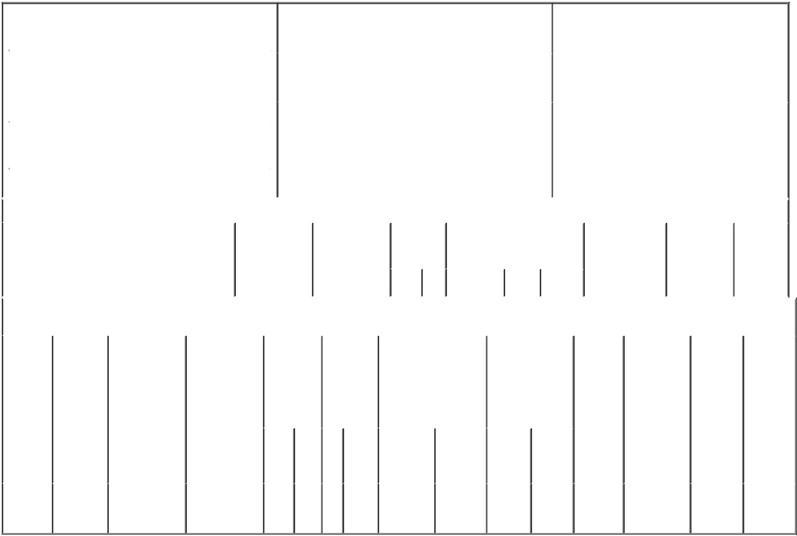

 | 1. Name and Address of Reporting Person* |  |  |  |  |  |  |  |  |  | 2. Issuer Name and Ticker or Trading Symbol |  |  |  |  |  |  |  |  | 5. Relationship of Reporting Person(s) to Issuer
 |  | Lukatch Heath |  |  |  |  |  |  |  |  | Vaxcyte, Inc. [ PCVX ] |  |  |  |  |  |  |  |  | (Check all applicable)
 |  |  |  |  |  |  |  |  |  |  |  |  |  |  |  |  |  |  |  | X Director |  |  |  |  |  | 10% Owner
 |  |  |  |  |  |  |  |  |  |  |  |  |  |  |  |  |  |  |  |  |  |  | Officer (give title |  |  | Other (specify
 |  |  |  |  |  |  |  |  |  |  | 3. Date of Earliest Transaction (Month/Day/Year)
 |  | (Last) |  |  | (First) |  | (Middle) |  |  |  |  |  |  |  |  |  |  |  |  |  |  |  | below) |  |  | below)
 |  |  |  |  |  |  |  | 06/02/2021
 |  | C/O VAXCYTE, INC.
 |  | 353 HATCH DRIVE
 |  |  |  |  |  |  |  |  |  |  | 4. If Amendment, Date of Original Filed (Month/Day/Year) |  |  |  |  |  |  |  |  | 6. Individual or Joint/Group Filing (Check Applicable
 |  |  |  |  |  |  |  |  |  |  |  |  |  |  |  |  |  |  |  | Line)
 | (Street) |  |  |  |  |  |  |  |  |  |  |  |  |  |  |  |  |  |  | X Form filed by One Reporting Person
 |  | FOSTER CITY CA |  |  |  |  | 94404 |  |  |  |  |  |  |  |  |  |  |  |  |  |  |  | Form filed by More than One Reporting
 |  |  |  |  |  |  |  |  |  |  |  |  |  |  |  |  |  |  |  |  |  |  | Person
 |  | (City) |  |  | (State) |  | (Zip)
 |  |  |  |  |  | Table I - Non-Derivative Securities Acquired, Disposed of, or Beneficially Owned
 | 1. Title of Security (Instr. 3) |  |  |  |  |  | 2. Transaction |  |  |  |  | 2A. Deemed |  | 3. |  |  | 4. Securities Acquired (A) or |  |  |  |  |  | 5. Amount of |  | 6. Ownership |  | 7. Nature
 |  |  |  |  |  |  | Date |  |  |  |  | Execution Date, |  |  | Transaction |  | Disposed Of (D) (Instr. 3, 4 and |  |  |  |  |  | Securities |  | Form: Direct |  | of Indirect
 |  |  |  |  |  |  | (Month/Day/Year) |  |  |  |  | if any |  |  | Code (Instr. |  | 5) |  |  |  |  |  | Beneficially |  | (D) or Indirect |  | Beneficial
 |  |  |  |  |  |  |  |  |  |  |  | (Month/Day/Year) 8) |  |  |  |  |  |  |  |  |  |  | Owned Following |  | (I) (Instr. 4) |  | Ownership
 |  |  |  |  |  |  |  |  |  |  |  |  |  |  |  |  |  |  |  |  |  |  | Reported |  |  |  | (Instr. 4)
 |  |  |  |  |  |  |  |  |  |  |  |  |  |  | Code V |  | Amount | (A) or | Price |  |  |  | Transaction(s)
 |  |  |  |  |  |  |  |  |  |  |  |  |  |  |  |  |  | (D) |  |  |  |  | (Instr. 3 and 4)
 |  |  |  |  |  | Table II - Derivative Securities Acquired, Disposed of, or Beneficially Owned
 |  |  |  |  |  |  | (e.g., puts, calls, warrants, options, convertible securities)
 | 1. Title of |  |  | 2. |  | 3. Transaction | 3A. Deemed | 4. |  |  |  | 5. Number |  | 6. Date Exercisable and |  |  |  | 7. Title and Amount |  |  |  | 8. Price of |  | 9. Number of |  | 10. | 11. Nature
 | Derivative |  |  | Conversion |  | Date | Execution Date, | Transaction |  |  |  | of |  | Expiration Date |  |  |  | of Securities |  |  |  | Derivative |  | derivative |  | Ownership | of Indirect
 | Security |  |  | or Exercise |  | (Month/Day/Year) | if any | Code (Instr. |  |  |  | Derivative |  | (Month/Day/Year) |  |  |  | Underlying |  |  |  | Security |  | Securities |  | Form: | Beneficial
 | (Instr. 3) |  |  | Price of |  |  | (Month/Day/Year) | 8) |  |  |  | Securities |  |  |  |  |  | Derivative Security |  |  |  | (Instr. 5) |  | Beneficially |  | Direct (D) | Ownership
 |  |  |  | Derivative |  |  |  |  |  |  |  | Acquired |  |  |  |  |  | (Instr. 3 and 4) |  |  |  |  |  | Owned |  | or Indirect | (Instr. 4)
 |  |  |  | Security |  |  |  |  |  |  |  | (A) or |  |  |  |  |  |  |  |  |  |  |  | Following |  | (I) (Instr. 4)
 |  |  |  |  |  |  |  |  |  |  |  | Disposed |  |  |  |  |  |  |  |  |  |  |  | Reported
 |  |  |  |  |  |  |  |  |  |  |  | of (D) (Instr. |  |  |  |  |  |  |  |  |  |  |  | Transaction(s)
 |  |  |  |  |  |  |  |  |  |  |  | 3, 4 and 5) |  |  |  |  |  |  |  |  |  |  |  | (Instr. 4)
 |  |  |  |  |  |  |  |  |  |  |  |  |  |  |  |  |  |  | Amount
 |  |  |  |  |  |  |  |  |  |  |  |  |  |  |  |  |  |  | or
 |  |  |  |  |  |  |  |  |  |  |  |  |  |  |  |  |  |  | Number
 |  |  |  |  |  |  |  |  |  |  |  |  |  | Date |  | Expiration |  |  | of
 |  |  |  |  |  |  |  | Code V |  |  |  | (A) (D) |  | Exercisable |  | Date |  | Title | Shares
 | Stock
 | Option |  |  | $21.49 |  | 06/02/2021 |  |  | A |  |  | 15,000 |  | (1) |  | 06/01/2031 |  | Common | 15,000 |  |  | $0.00 |  | 15,000 |  | D
 | (right to |  |  |  |  |  |  |  |  |  |  |  |  |  |  |  |  | Stock
buy)

Explanation of Responses:

- The shares subject to the option will vest monthly and fully vest on the earlier of June 2, 2022 or the day prior to the next annual meeting of stockholders, subject to the Reporting Person's continuous service through such date.

Remarks:

/s/ Ron Metzger, Attorney-in- |  |  | 06/03/2021
Fact
** Signature of Reporting Person |  |  | Date

Reminder: Report on a separate line for each class of securities beneficially owned directly or indirectly.

* If the form is filed by more than one reporting person, see Instruction 4 (b)(v).

- Intentional misstatements or omissions of facts constitute Federal Criminal Violations See 18 U.S.C. 1001 and 15 U.S.C. 78ff(a). Note: File three copies of this Form, one of which must be manually signed. If space is insufficient, see Instruction 6 for procedure.
Persons who respond to the collection of information contained in this form are not required to respond unless the form displays a currently valid OMB Number.

